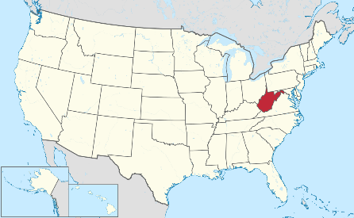Novruz G. Akhmedov, *Ph.D.*

NMR Research Associate

Director of NMR Facility

NMR website: <http://nmr.wvu.edu>

West Virginia University, Department of

Chemistry, 217 Clark Hall, Morgantown, WV 26506-604

*Office*: CRL (Chemistry Research Laboratory), room #259

*Phone*: 304 293 0918; *Fax*: 304 293-4904

**WVU Chemistry NMR Facility**

**Usage and Service Fee for different type of NMR users**

|  |  |  |  |
| --- | --- | --- | --- |
| User | 400 MHz  Agilent | 400 MHz  JEOL | 600 MHz  INOVA |
| Internal (Chemistry Dept) | $ 5/hr | $ 5/hr | $ 10/hr |
| WVU and affiliated institutions | $ 10/hr | $ 10/hr | $ 16/hr |
| External academic institutions | $ 40/hr | $ 40/hr | $ 50/hr |
| Industrial / private companies | $ 75/hr | $ 75/hr | $ 100/hr |
| Routine service fee: $20/sample for facility personnel to acquire each spectrum for external users | | | |
| Expert services: $200/hour for problem-solving, analysis, and solutions to research challenges | | | |

**Routine services**: The NMR Facility offers the following common NMR experiments, along with helpful tips and suggestions as appropriate. The resulting spectra are provided as PDFs and/or as an FID file, without detailed interpretation:

**1D NMR**: 1H, 1D NOESY, 1D ROESY, 1D TOCSY, 13C, APT, DEPT90, DEPT135, 19F, 31P, 11B, and 29Si etc;

**2D NMR-gradient selected**: gCOSY, gDQCOSY, TOCSY, gDQCOSY, NOESY, ROESY, gHSQC, gHMBC, gH2BC, gHSQC-TOCSY etc.

**Expert services**: The NMR Facility staff provides expert services to assist with the identification and full characterization of unknown samples. Such services include experiment design; data acquisition, processing, presentation, and storage; and full interpretation.

**Research Collaboration**: The Facility Manager may engage collaboratively on a case-by-case basis with WVU Chemistry research efforts. Such efforts are expected to result in peer-reviewed publications that enhance the visibility and impact of the facility and department. Service fees are not applied to research collaborations, although instrument time is still charged.

