



**Reservation of NMR time is done online, using the Faces Scheduling System software; to reserve time in our instruments please follow the link below:**

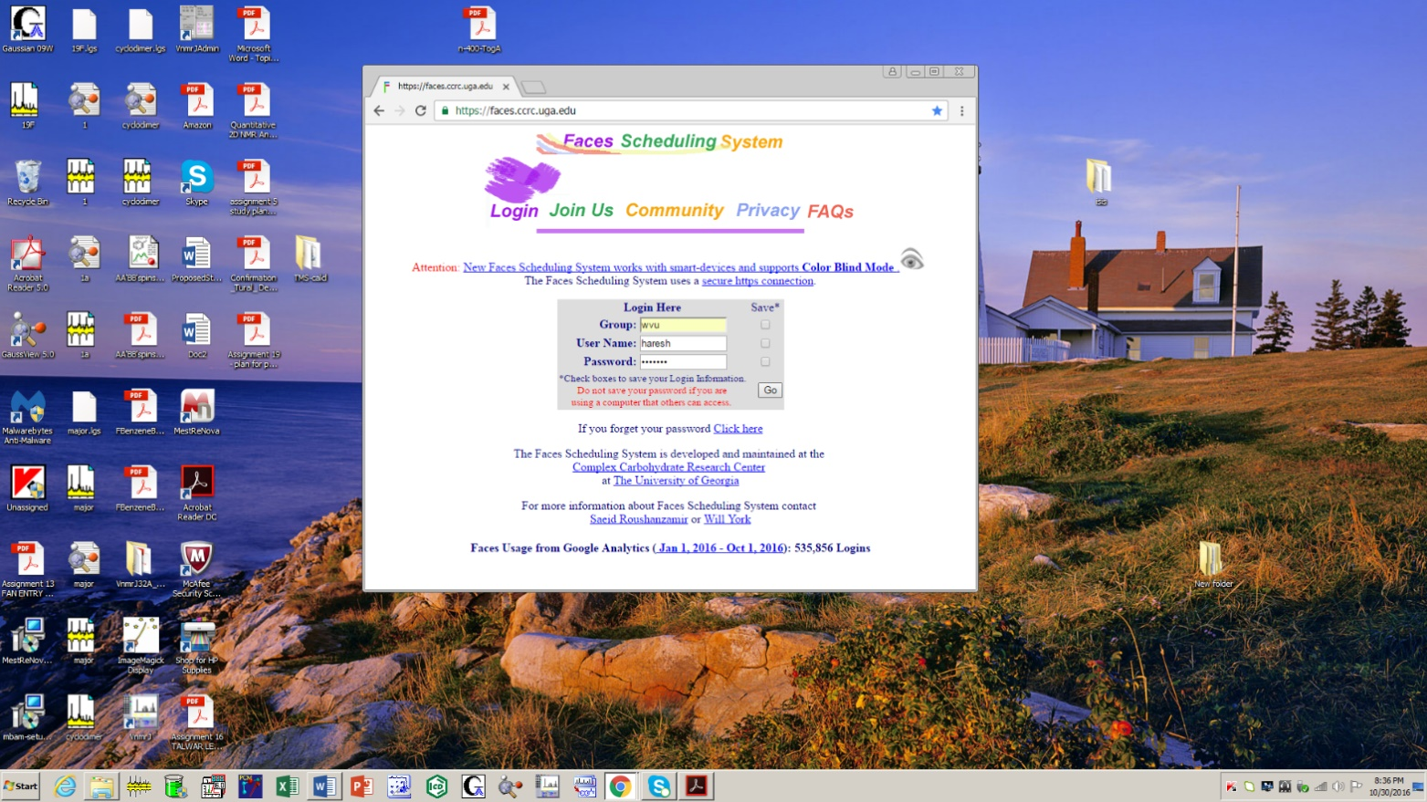http://faces.ccrc.uga.edu/

After your initial NMR training you will receive an email

with your *User Name* and a *Password*,

which you should change at your first login.

The NMR schedules are hosted at the CCRC at UGA:

http://faces.ccrc.uga.edu/

When you click “Go” after entering the proper Login

information you will see the “Welcome Screen.” Click Choose a Schedule; you will see a pull down menu

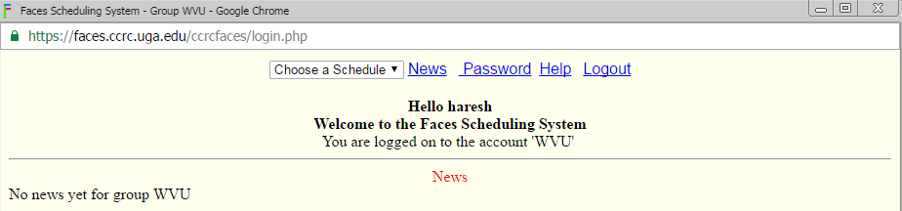.

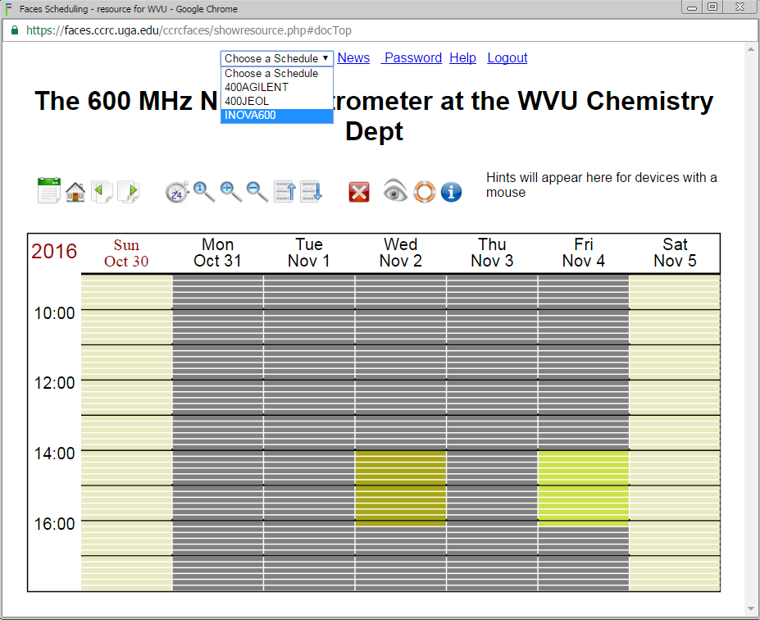Click once on an open slot to choose the starting time.

You will see a yellow highlight. You can move the mouse

down to extend your time. Click again to continue the

Reservation. Reserved time is shaded in a yellow color.

Grey blocks are available slots.

Make sure you finish your reservation by clicking on the

“Go” button.

Read the next page carefully. This what you should see if

you were successful. It there was a problem this page will

inform you why your request failed.

